Phil Uden has passed on some sad news about Bob Cheesley.

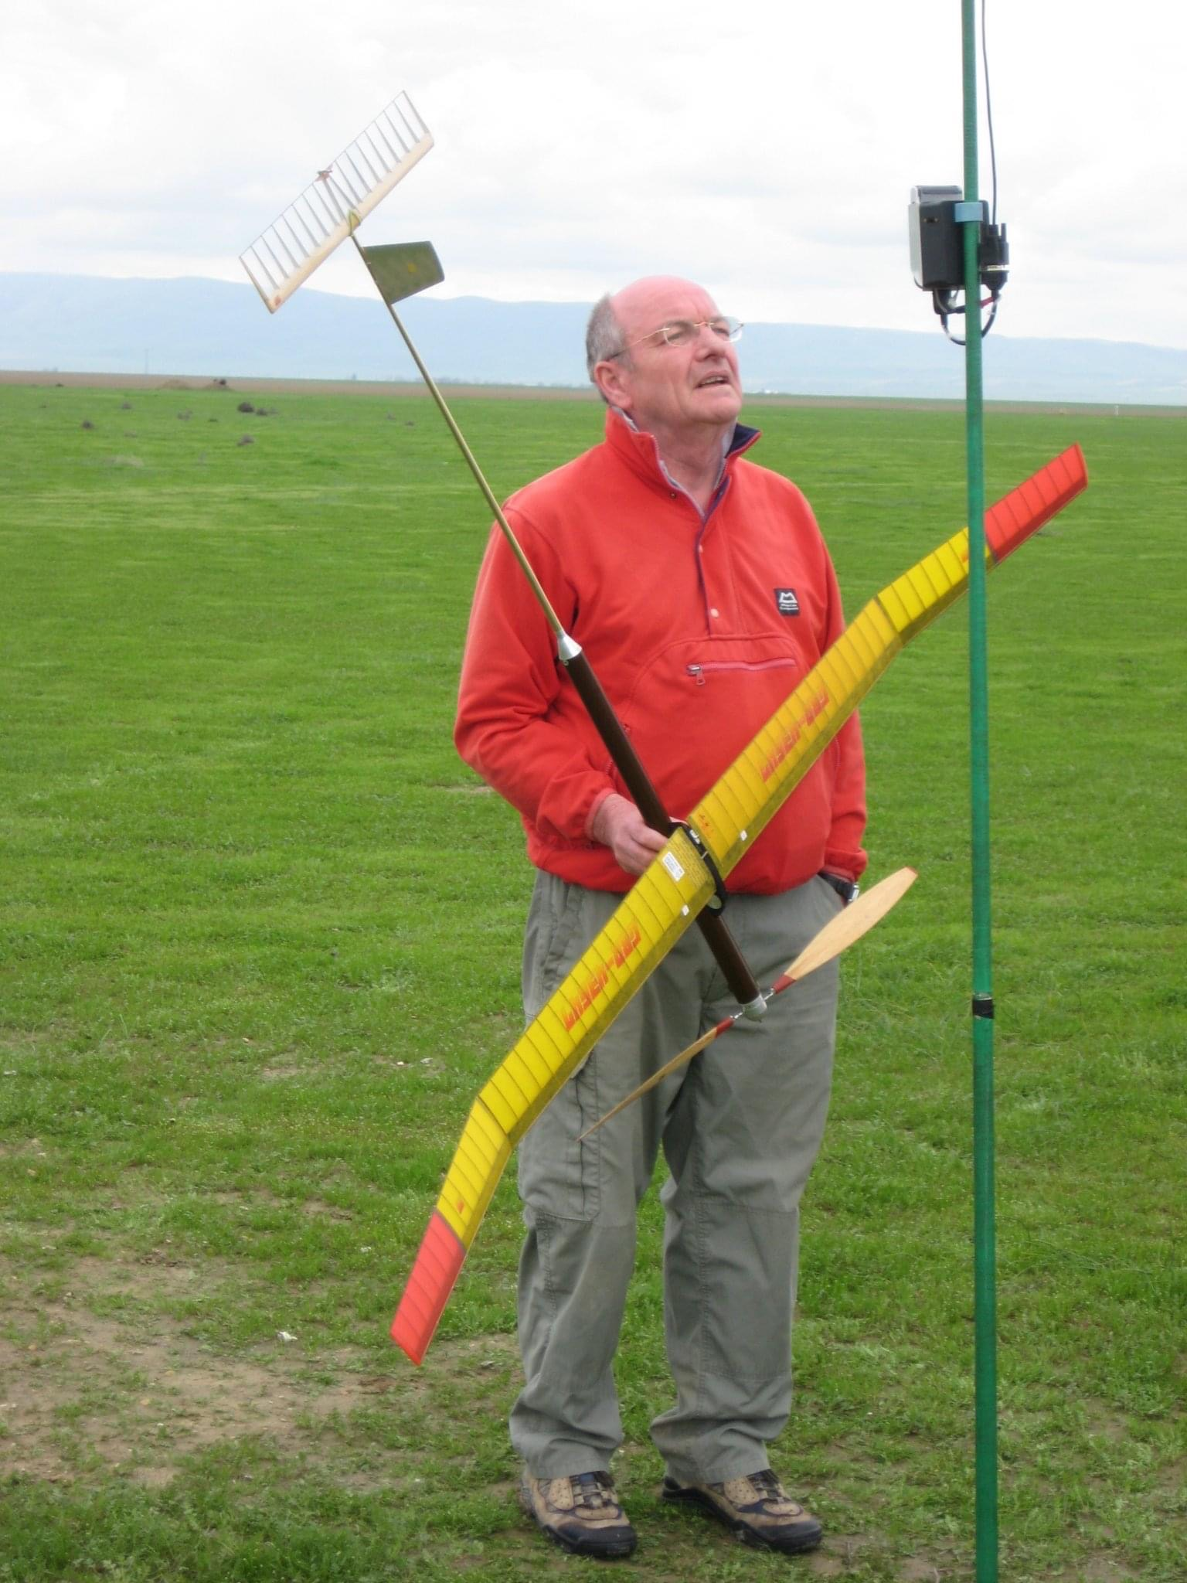
Bob Cheesley passed away on 3rd August after a long illness. He will be remembered on the flying field for his wonderful sense of humour and comradeship. Bob mainly flew F1B Wakefield and always showed great innovation especially in the early days of composite materials. He was a member of 1997 FIB team at the World Championships in Czechoslovakia and was assistant or team manager on various other occasions. Although he retired from flying after a foot injury, he kept in touch with his flying friends and often helped, gave advise or just had a chat. Bobs’ other love was engineering and his workshop, where he built amongst other things stationary steam engines. The precision was amazing. He will be sorely missed.

