BMFA Free Flight Tech Committee News. Issue 137
All correspondence re this news to the FFTC Secretary:
Simon Dixon, 8 Capulet Drive, Bards Meadow, Warwick Gate, Warwick CV34 6EW
email;- bmfafftc@outlook.com

FFTC 2025 CALENDAR
FFTC 2025 CALENDAR V3
Date | Venue | Event | Classes | Contact
23-25 August | Sculthorpe | Nationals | All classes. See separate programme | Michael Woodhouse, michaelwoodhouse1942@gmail.com
7 September | Area | 7th Area | Open (Frog Senior, Plugge), FAI (K&MA, Plugge), Vintage/Classic, Mini, Micro. | Area
13-14 September | Sculthorpe | Stonehenge and Equinox Cups | FAI. | Peter Martin ffworldcupuk@gmail.com
13-14 September | Midland Rocket Club, Twycross | Second Space Team Selection and  Nationals | S1, S3, S4, S5, S6, S7, S8, S9 | Slawomir Zach  slawomirzach@gmail.com  Trevor Seabrook  contacttrevorseabrook@gmail.com
27-28 September | Sculthorpe | Team Selection Reserve | FAI.
27-28 September | Sculthorpe | Space Team Selection Reserve | S1, S3, S4, S5, S6, S7, S8, S9 | Slawomir Zach  slawomirzach@gmail.com
27-29 September | Near Melton Mowbray or Peak District | 6th F1E | F1E Team selection | Ian Kaynes  kaynes@btinternet.com
12 October | Area | 8th Area | Open, FAI (Mick Duce, Plugge), Vintage/Classic, Mini (Plugge), HLG/CLG. | Area
19 October | Buckminster |  | Free Flight Conference | Simon Dixon BMFAFFTC@outlook.com
25 or 26 October * | North Luffenham | Midland Gala | Vintage/Classic, Mini, Micro, HLG/CLG. | Phil Ball phil.ball@ntlworld.com
15 or 16  Alternate  22 or 23  November | Buckminster | Mini Gala | Combined P30/ Coupe d'Hiver, Classic A1 Glider, BMFA Classic Glider (50m. line), E36 (5 sec. run), Mini- Vintage, HLG/ CLG | Simon Dixon BMFAFFTC@outlook.com  CD TBC
*Team Selection fall back date

RULE CHANGES
Rule and Calendar changes for next year will be discussed at the Conference on the 19th October at Buckminster. Please attend the conference if you wish to make a positive contribution.
2025 FREE FLIGHT NATIONALS
Free Flight Nationals 2025
Three days
Saturday 23rd August to Monday 25th August

Venue
All three days to be at Sculthorpe, North Norfolk.

Facilities and access
- There will be no camping or overnight stay allowed on the airfield. There will be no facilities except for the provision of toilets.
- No dogs under any circumstance are allowed on the field.
- All attendees must be BMFA members and must have their membership card with them. Family members are permitted access.

Payments
- There is a no pre-entry requirement. Pay on entry on the day, cash only. The fee will be a simple £10.00 per day charge. This fee allows the entrant to fly in as many events as they desire. BMFA season ticket holders will be required to pay the entry fee.
- A discounted payment of £25.00 will cover all three days.
- The fee covers entry into all free flight, space, Bowden and scale events.
- Casual sport flyers will be required to pay the same entry fees.

Free Flight Open, FAI and mini classes

Saturday 23rd August  Start 10:00 – 18:00 | Sunday 24th August  Start 10:00 – 18:00 | Monday 25th August  Start 10:00 –18:00
Open Glider | F1A Glider | F1H glider
Open Rubber | F1B Rubber | F1G rubber
Open Power | F1C Power | F1J Power
Open Electric | F1Q Electric | BMFA 1/2A Power
Classic Rubber/Power | Vintage Rubber/Power | E36 Electric
Women's Cup | Slow Open Power | P30 Rubber
Catapult Glider CLG | Classic Glider | E30 Electric
Frog Junior (J) |  | Mini Vintage
Tailless |  | CO2 Duration
Vintage Glider |  | Hand Launched Glider HLG

- The open classification covers all models flown to their class specific rules. E36 flown in open electric will be allowed a full motor run the unlimited fly off.
- The max for all classes to be decided on the day.
- Dependant on the weather the number of flights in the “F” classes to be decided on the day. Also, weather dependant, there may either be no rounds or 2 flights before 13:00.

Free Flight Overall Championships

Championship | Saturday | Sunday | Monday
Rubber | Open Rubber | F1B | F1G, P30
Glider | Open Glider | F1A | F1H, Classic Glider
Power | Open Power | F1C | F1J, SLOP
Electric | Open Electric | F1Q | E36, E30

- Points – 9, 6, 4, 3, 2, 1. As per the Senior Championships. If less than 6 persons fly the scores will be reduced bottom up.
- In the event of a tie the placings will be decided on the number of entries in the classes flown. If a tie persists, then the longest fly off score to decide.

Bowden Trophy and Stan Horne Memorial – Sunday 24th August

The Bowden Trophy will be run by the Peterborough who will in addition run the Stan Horne memorial event. The 250gramme Rule does not apply to the Bowden Trophy or Stan Horne Memorial.

Scale – Saturday 23rd August

- FF2 Scale Free Flight contest for the Selby Trophy.
- FF3 Rubber Precision contest for the Rubber Precision Trophy.
The scale events will be run by the Scale Technical Committee.

Awards

- Certificates and medals will be awarded to all events.

NOTE: ABSOLUTELY NO DOGS OR ANY OTHER PET ANIMALS WILL BE ALLOWED ON SCULTHORPE. THIS INCLUDES LEAVING THEM IN THE CAR.

TEAM MANAGEMENT FOR 2026 CHAMPIONSHIPS
Applications are invited for the posts of Team Manager and Assistant Team Manager for the 2026 World Championships for F1A, F1B F1C and F1Q to be held in North Macedonia. The dates are yet to be confirmed by the organisers.
Closing date for applications to be received is the end of November 2025.

THE STONEHENGE AND EQUINOX CUPS 2025

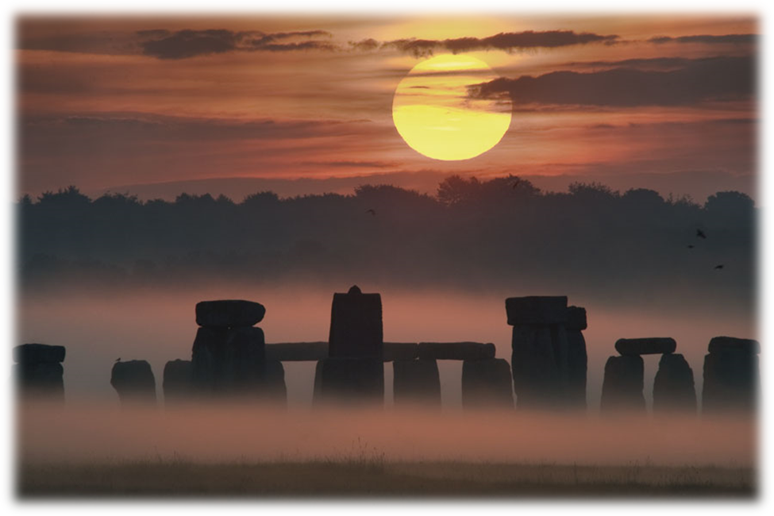
THE STONEHENGE CUP
& EQUINOX CUP
2025
U.K. World Cup Free Flight Events
13th/14th September 2025 RAF Sculthorpe
United Kingdom

World Cup Events

Saturday 13th Sept 2025 Stonehenge Cup F1A, B, C and Q
Sunday 14th Sept 2025 Equinox Cup F1A, B, C and Q

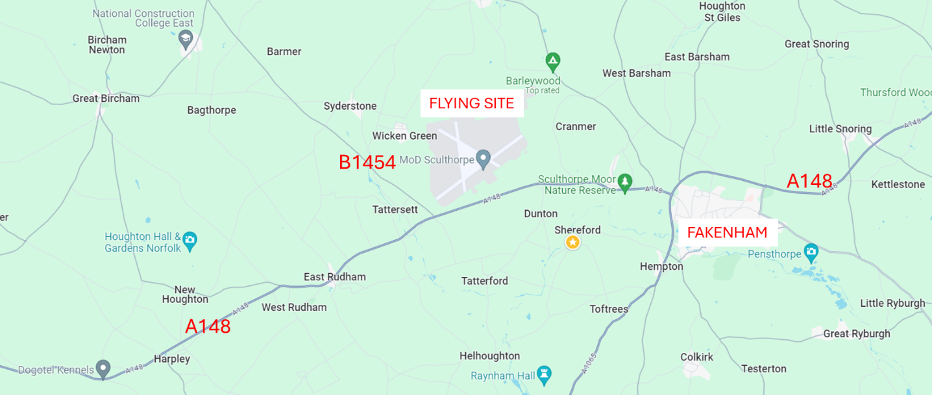

Flying Site

The flying site is situated to the North of the A148 between Fakenham and King's Lynn, just East of the B1454 to Docking and Hunstanton, it will be signposted. GPS coordinates for the site entrance are 52°50’12.73”N, 0°44’44.7”E (decimal 52.83687, 0.74575).

The terrain is mostly short grass, with a mixture of paved runway and perimeter track - Contestants must not drive or park on the runways at any time. The land is a military training area, which is carefully managed to preserve the infrastructure and wildlife. Strictly no dogs are permitted on site, even within cars. Model retrieval is on bicycle or foot. The area must be kept clean and tidy at all times and rules to protect the site must be observed. Please note-there are no catering facilities available - competitors must bring their own food and drink.

Programme
Events will start at 09.00. There will be 5 rounds plus fly-offs flown from a flight line. The Max for round 1 will be 240 seconds. All other rounds will be 180 seconds Max. These maximum times and program may vary according to circumstances.
Rules
The relevant section of the FAI Sporting Code will be followed. All competitors must hold a valid FAI licence and FAI ID number. F1Q will be flown to the 2 Joules / 20 seconds rule.
Entry Procedure
There is an online entry form with card payment at
https://freeflight.bmfa.uk/2025-stonehenge-equinox.

Alternatively, competitors from the UK who wish to compete in either or both events can post their entry forms to:-

Peter Martin, 23 Woodland Court, Dyke Road Avenue, Hove, UK, BN3 6DP complete with payment cheque made out to 'BMFA'.
Competitors residing outside the UK can email their completed entry form(s) to ffworldcupUK@gmail.com.

Overseas entry fees may also be paid on the day in £ or Euros.
Entries must be received by no later than Friday 5th September 2025

Trophies
These will be awarded down to 3rd place for each class.
Timekeepers
Timekeepers will not be provided by the organisers for the rounds. Competitors must find their own timekeepers. Timekeepers will be allocated by the organisers for fly-offs.
F1Q
F1Q will be flown to 2 Joules.
Only fully compliant models will be included in the results.
For further information please contact:-
Peter Martin or Richard Jack ffworldcupuk@gmail.com

STONEHENGE CUP + EQUINOX CUP ENTRY FORM 2025

Full Name
Address
Town/City
Country |  |  | Post/Zip Code
Nationality |  |  | Senior/Junior
Telephone No. |  |  | Mobile No.
Email Address
FAI ID Number |  |  | BMFA No.

World Cup Events

 | Stonehenge Cup – Event 1 |  |  |  | Equinox Cup – Event 2
Day | SAT  13th | SAT  13th | SAT  13th | SAT  13th | SUN  14th | SUN  14th | SUN  14th | SUN  14th
Class | F1A | F1B | F1C | F1Q | F1A | F1B | F1C | F1Q
Please tick

Entry Fees

World Cup Event Single Class (Seniors) | €35/£30  (€70/£60 both events)
World Cup Event Single Class (Juniors)  (Junior aged 18 or under on 31st Dec 2025). | Free
Additional classes within each Event (Seniors) | Free
Additional classes within each Event (Juniors) | Free
 | Total Paid*
(*Entry fee is included in the UK Contest License Holders fee, no additional payment is required)

UK Competitors post to - Peter Martin, 23 Woodland Court, Dyke Road Avenue, Hove, UK, BN3 6DP complete with payment cheque made out to 'BMFA'.

Competitors resident outside of the UK should email their completed entry form(s) to ffworldcupUK@gmail.com

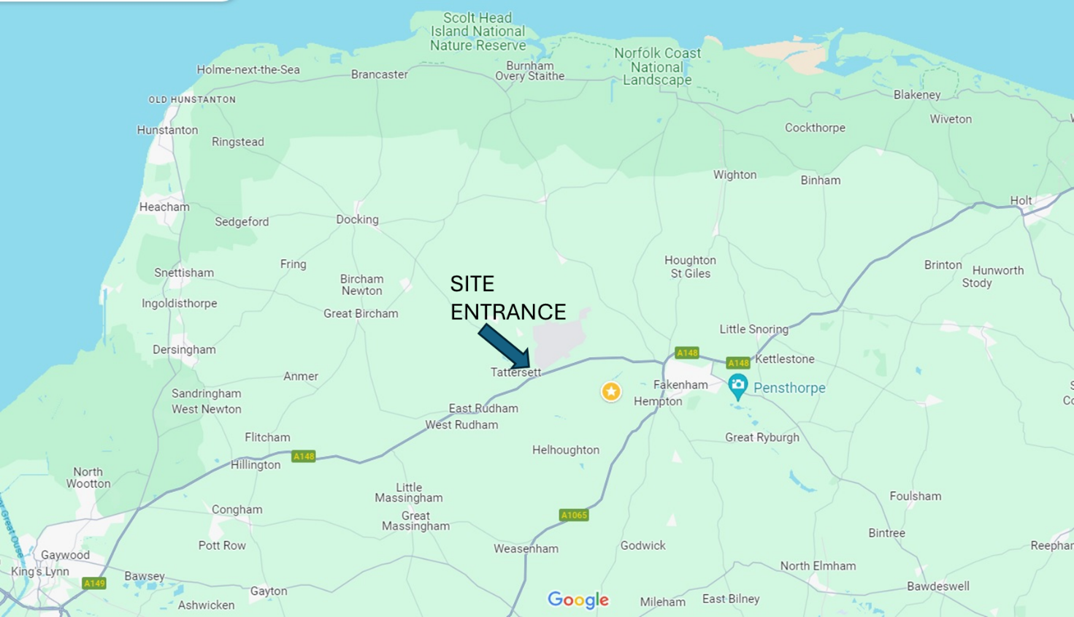
Location Map

